Da’Ron George

February 4 2019

My name is Da’Ron George, I am 16 years old, and I am from The San Fernando Valley. Growing up in the valley wasn’t to bad but was always a struggle. A single mother fighting everyday to pay the rent on time as well as keeping about five kids fed daily. As a youth noticing the pain and struggle in my mother’s eyes didn’t come around as often but when it did it was sad to see my mom hold in all that pain. Elementary was cool it was never that hard for me to find friends but as people say I fell in with the wrong “crowd” . Teachers were hard because the seen the pontinal I had, and what I was capable of accomplishing. Jumping to age ten, out with a friend trying to escape the beauties of poverty, my friend and I find ourselves inside of Macy’s trying to steal a bootleg watch to feel better about our shortcomings in life so we go on with the plan. Only setting ourselves up for failure we were taken down to a holding cell were had to call our parents to come pick us up. Nervous and anxious “ What’s your parents number” I don’t know “ Well if you don't know the police will come pick you up and take you home”. Riding in the back of a police car is a uncomfortable feeling, the seats are hard and the officers are assholes. One of the officers went to go get my mom from upstairs and the disappointment on her face hurt more than any discipline she had in mind could. Fast forward to middle school I listen to some of my teachers and staff members tell me I will not be anything in life and that I will end up like my older brother. Fortunately for me I used that as a motivator instead of a downer. As I moved through the six grade we were evicted out of our apartment and lived in a motel until my mom finally found a place in Los Angeles. Moving to L.A was a big difference for me, not knowing what to expect, nothing but the stories of what goes on from other people who know about it. Seventh grade was the year for me, fights came my way issues came my way and a cool set of people came my way. Im grateful for L.A though it made more independent, it made me more aware of my surroundings, and it showed me how real life really is. Jumping right into it I was surrounded by people who wanted better for themselves but didn´t know a better way of going to get it. As I watch and learn I knew it wasn't right but I followed and did what I did anyway. From taking what doesn't belong to me, to fighting and disrespecting anybody who disrespected or I felt like disrespected me. I always been quite insightful and contemplating the consequences of my actions. As I moved forward I still could not let anybody disrespect the people I call brothers in return it was vice versa. So a group of young black males standing as one is what were in those moments. From being at school picking fights, to smoking marijuana chilling with some friends. Academically wise school have never been a problem for me, my problem was knowing when and when not to go off on students as well teachers and staff members. As kid I still knew what I wanted and what I needed to help me in some of the situations i was in. One thing I never knew i had until about middle school was I had a IEP. A IEP is just something that tells the teachers and staff members that I need a little more help and attention. Sometimes going home hungry just to see there's nothing in the refrigerator and no EBT makes you want to steal. Another thing I notice is that society and social peers play a key factor in a kids life. Like for example if you see yourriend or a kid that has the newest iphone out or the newest pair jordans on their feet it makes you want that as well. So kids use that motivation to go take something or somebody else's property. Instead of asking for a program that can help then get a job and give them life skills. For me I have been on probation for about two years now, with no experience gained from my probation officer except that I am a juvenile instead of a young black male. I've been put in numerous programs to show the system that I am not another statistic even though I knew that from the start. Kids my age make a lot of mistakes that should not mean that it defines who you are or will grow to be. My first time getting in trouble with the law I had teen court and you could say they let me off with a warning but I had a hundred hours of community service to complete. I was good the whole your until about two months before I was about to get of probation. My brother called his girlfriend to the park right down the street from my house. It was late but at the time we all wanted to smoke some weed. Her sister and cousin didnt want to smoke so I got agitated and wanted to go home. Unfortunately my sister and my brothers girlfriend didn't get along. So when my sister heard they was downstairs, she went downstairs and they got into a altercation with one another. While that altercation was happening I was upstairs in my room. Her cousin must have lost her phone in that fight trying to break it up. Unfortunately for me she said that I took it. About three months later my brother and I were picked up from school by about twelve officers and were taken down to the station. This situation changed my whole life and in alot if ways took me back to the streets and not into a stable environment, and not a stable family because my mom already worked so much and and she felt that I was not someone she could trust so our relationship was just non existing.

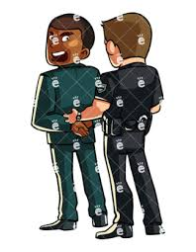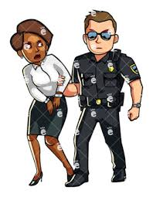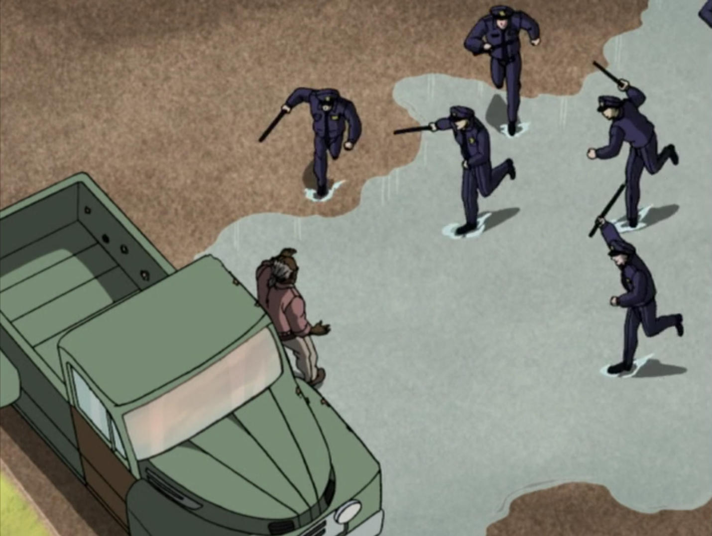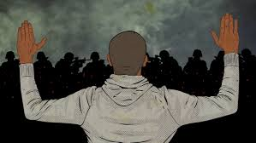

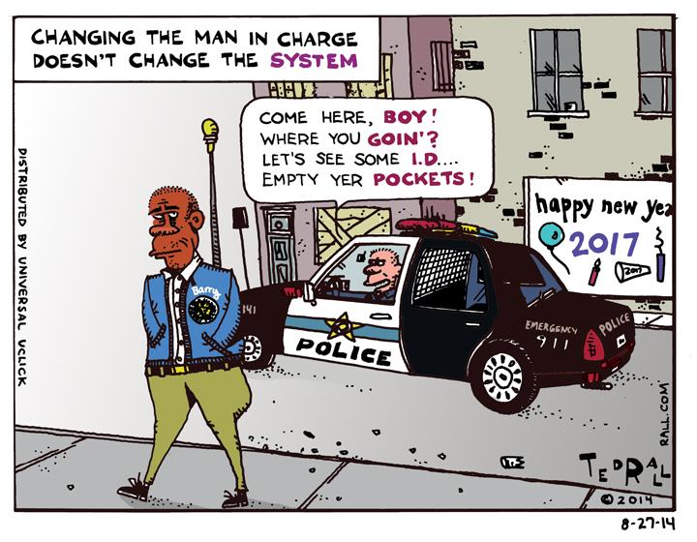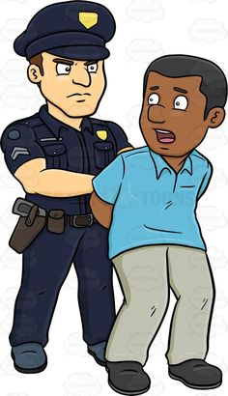

Image 1 : In the picture there’s a white officer who has a African American male business man in handcuffs. Some people really are doing well for themselves, and most white officers don't like seeing that in low-income communities, so they find any reason to arrest men of this nature.

Image 2 : In this picture is a young black women who is just trying to make sure the people in her community are safe and well treated to their rights and instead the officers wants to be assholes and put the women in handcuffs.

Image 3 : Whenever officers pull over kids or jump out their car on people standing in front of their homes they come about four deep and if they are not already thick enough they call about three more other cars for backup for no apparent reason.

Image 4 : This picture is a black men or boy standing at a peace movement praying the officers don't feel “threatened’ and shoot into the crowd, all he want is justice and for the system to treat us as equal.

Image 5 : In this photo this something that happens very often in my community, such as officers harassing people as if they are criminals and telling people to empty there as if the were gang members.

Image 6 : Shows another white officer arresting a black man for no reason, all these photos are representing me and other peers and people in my community and thank you for letting me share my story.

Da’Ron George

February 4 2019

My name is Da’Ron George. I am 16 years old, and I am from the San Fernando Valley. Growing up in the Valley wasn’t to bad but it was always a struggle. My mom was a single mother fighting everyday to pay the rent on time, as well as keeping five kids fed daily. As a youth noticing the pain and struggle in my mother’s eyes was sad to see. It was a struggle to watch my mom hold in all that pain.

Elementary was cool. It was not that hard for me to find friends, but as people say, I fell in with the “wrong crowd” . Teachers were hard on me because they saw the pontinal I had and what I was capable of accomplishing. Jumping to age ten, I was out with a friend trying to escape the ugliness of poverty and we found ourselves inside of a Macy’s trying to steal a bootleg watch to feel better about our shortcomings in life. We went on with the plan only to set ourselves up for failure. We were taken to a holding cell where had to call our parents to come pick us up. I was nervous and anxious when the mall cops asked, “What’s your parents number?” “I don’t know,” I responded. “Well if you don't know, the police will come pick you up and take you home”. Riding in the back of a police car is an uncomfortable feeling; the seats are hard and the officers are assholes. One of the officers went to go get my mom from upstairs and the disappointment on her face hurt more than any discipline she had in mind.

Fast forward to middle school and some of my teachers and staff members would tell me that I would not be anything in life and that I will end up like my older brother. Fortunately for me I used that as a motivator instead of a downer. As I moved through the sixth grade we were evicted out of our apartment and lived in a motel until my mom finally found a place in Los Angeles. Moving to L.A. was a big difference for me. I did not know what to expect. All I heard were stories of what goes on from other people who know about it. Seventh grade was the year for me. Fights came my way, issues came my way, and a cool set of people came my way. I am grateful for LA though. It made me more independent, it made me more aware of my surroundings, and it showed me how life really is.

Jumping right into it, I was surrounded by people who wanted better for themselves but did not know a better way of going to get it. As I watched and learn, I knew it wasn't right but I followed and did what I did anyway. From taking what doesn't belong to me to fighting and disrespecting anybody who disrespected or I felt disrespected me. I have always been quite insightful and have always contemplated the consequences of my actions. As I moved forward I still could not let anybody disrespect the people I call brothers -- in return it was vice versa. So a group of young black males standing as one is what those moments were made of. I would be at school picking fights and smoking marijuana, chilling with some friends. Academically, school has never been a problem for me. My problem was not knowing when and when not to go off on students as well as teachers and staff members. As a kid I still knew what I wanted and what I needed to help me in some of the situations I was in.

One thing I never knew I had until about middle school was an IEP. An IEP is just something that tells the teachers and staff members that I need a little more help and attention. Sometimes going home hungry just to see there's nothing in the refrigerator and no EBT makes you want to steal. Another thing I noticed is that society and social peers play a key factor in a kid;s life. For example, if you see your friend or a kid that has the newest iphone out or the newest pair Jordans on their feet, it makes you want that as well. So kids use that motivation to go take something or somebody else's property. We should be, instead, asking for a program that can help them get a job and give them life skills. For me I have been on probation for about two years now with no experience gained from my probation officer, except that I am a juvenile instead of a young black male. I've been put in numerous programs to show the system that I am not another statistic even though I knew that from the start. Kids my age make a lot of mistakes, but that should not mean it defines who you are or will grow to be. My first time getting in trouble with the law I had teen court and you could say they let me off with a warning, but I had a hundred hours of community service to complete.

I was good the whole year until about two months before I was about to get off probation. My brother called his girlfriend to the park right down the street from my house. It was late, but at that time we all wanted to smoke some weed. Her sister and cousin did not want to smoke so I got agitated and wanted to go home. Unfortunately, my sister and my brother’s girlfriend didn't get along. So when my sister heard they were downstairs she went downstairs and they got into an altercation with one another. While that altercation was happening I was upstairs in my room. My brother’s girlfriend’s cousin must have lost her phone in that fight trying to break it up. Unfortunately for me she said that I took it. About three months later my brother and I were picked up from school by about twelve officers and were taken down to the station. This situation changed my whole life and in alot of ways took me back to the streets. I was not in a stable environment and not in a stable family because my mom already worked so much, and she felt that I was not someone she could trust anymore so our relationship deteriorated.